Lab 4 – Power Supply Part 2

CE-3101/021 Digital Elex. and Comp. Interfacing

By:

Andrew Iliescu

4-19-2020

**Abstract:**

The ability to rapidly simulate circuits and make changes on the fly is an invaluable tool that has allowed us to analyze circuits rapidly and effectively. This is because of programs like Waveform and the Analog Discovery Kit which allow us to create circuits on a breadboard and then analyze their behavior on a computer. In this lab we are building a power supply using a breadboard, transformer, diodes, resistors, a filter, and a regulator. Then we can use the Analog Discovery kit and the Waveforms program to model what the voltage values look like. By adding the components in steps, we can see the role that each component plays in manipulating the voltage to make it closer to a DC source.

**Methods:**

Figure 1: Circuit diagram, taken from Ms.Varnell’s CE3101 Lab 4 document

The circuit in figure 1 was built on a breadboard and then analyzed using the waveforms program. First thing that was done was the bridge rectifier was built and tested. Then an oscilloscope was used to measure the actual voltage coming off of the transformer before it was attached to the rectifier. Then we connected the bridge rectifier with the transformer and verified that the transformer was inverting the negative portion of the power sinusoid. Next the filter was added which happened to be a 100F capacitor and a 100Ω 5W power resistor. We then verified that this load we introduced resulted in a value close to our calculated ripple voltage. We then went ahead and calculated the maximum and minimum currents experienced by the load resistor and the maximum and minimum powers experienced by the load resistor. Now it was time to add the 7805 regulator into the mix. We then went ahead and measured the voltage across the resistor and saw if we could identify any ripple. We again calculated the maximum and minimum current and power experienced by the load resistor. We then inserted an ammeter into the circuit to measure the current and verify it agreed with our calculations. Lastly, we replaced the 100Ω resistor with a 4.7kΩ and repeated the voltage and current measurements and calculations with this new load resistor to see how it would impact the ripple voltage of the circuit.

**Results:**

After conducting the lab, we were able to see how a power supply takes in an AC voltage from the power outlet and converts it to a constant DC voltage. The first part of the power supply circuit is the transformer that takes the power reduces it to 1/10 of its original value in our case (figure 2). This transformer then gets attached to the bridge rectifier portion of the power supply circuit to have the negative voltage values become positive. The transformer puts out around 13.7VRMS which is approximately 19.4Vpeak. This means that the rectified voltage is approximately 12.5 VRMS =17.7 Vpeak (figure 3).

Figure 2: This is the reading of a multimeter that is attached to the transformer in this lab

Figure 3: This is the voltage with the transformer and the bridge rectifier

The next portion of the power supply circuit is the filter. For this portion we used a 100F capacitor along with a 100Ω resistor. What the filter does is it decreases the change in voltage between the peaks because it stores some of the voltage that goes through the circuit so when the AC voltage drops the capacitor supplements the rest of the circuit with voltage that it had stored up. This results in a ripple voltage that begins to make the voltage coming off of the power supply circuit look more like a constant DC value. The resulting waveform simulation is shown in figure 4.

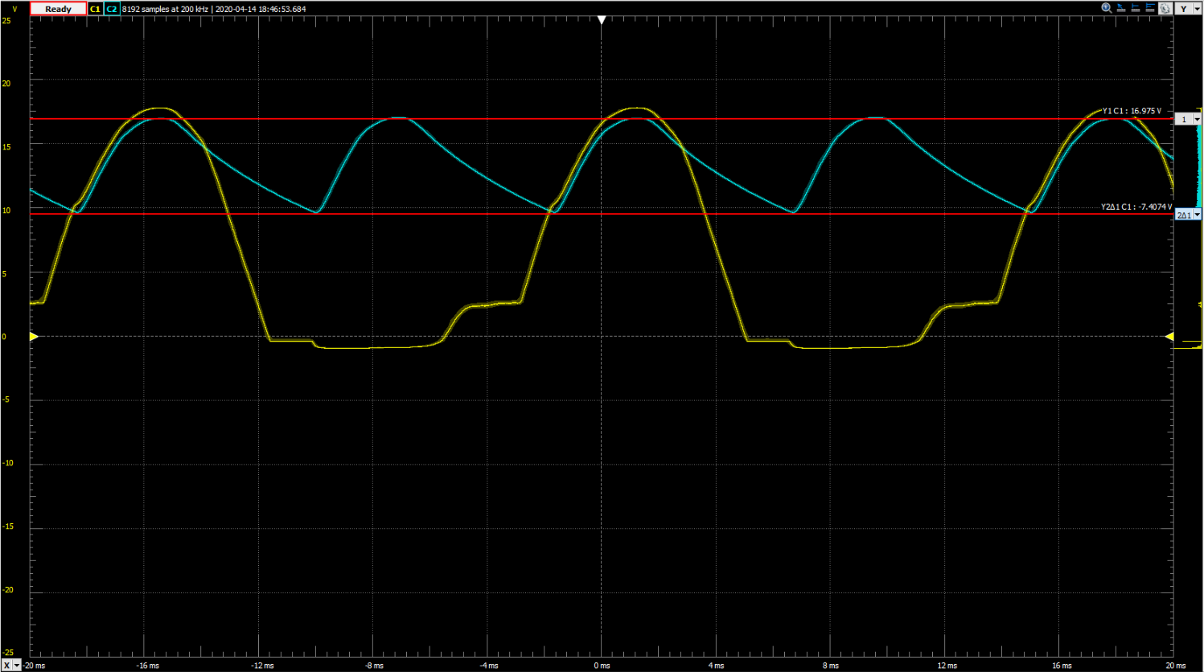

Figure 4: Circuit with the transformer, bridge rectifier, and filter attached to show the ripple voltage measurements

When calculating the expected ripple voltage, we get a value of 14.75V whereas the measured value is 7.4V. We can assume that this very large discrepancy is caused by the fact that the Analog Discovery kit cuts off the negative voltages. We then went ahead and used the ripple voltage, load resistor value, Ohm’s Law, and the power equation, which allowed us to calculate the maximum and minimum values for the current and power across the load resistor. The equations and calculations can be seen in figures 5-8.

(5)

(6)

(7)

(8)

Now the final component gets added to the power supply circuit. This component is the 7805 regulator. This final piece allows only a certain voltage value to be output, which is less than the trough of the ripple voltage. This means that the output is a constant DC voltage which is exactly what we are looking for. The resulting graph in Waveforms is shown in figure 9.

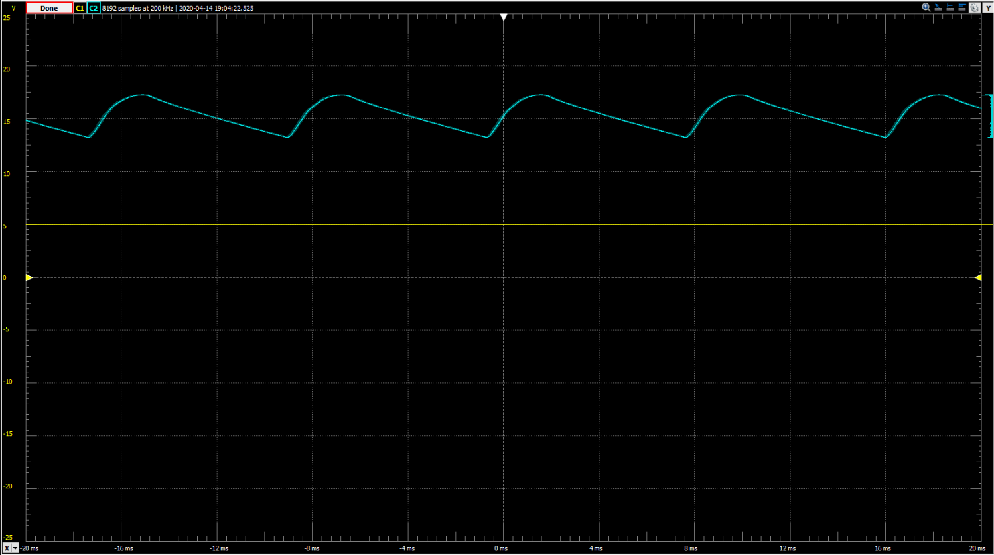

Figure 9: Waveforms graph depicting the ripple voltage and circuit voltage post regulator w/ 100Ω resistor

The maximum and minimum current and power values are again calculated across the load resistor using the new output value of 5 volts. These calculations are shown in figures 10-13.

(10)

(11)

(12)

(13)

As these calculations show, the voltage is constant so the minimum and maximum values for the current and the power are the same. This means that we achieved our goal of turning an AC voltage into a constant 5V DC voltage. We used an ammeter to measure the current across the circuit and the resulting value was 50.34mA which is almost identical to our expected value of 50mA. We then went ahead and replaced the 100Ω load resistor with a 4.7kΩ resistor. The resulting waveforms graph is shown in figure 14 and again we do the maximum and minimum current and power calculations in equations 15-18. The major change between the two resistors is the fact that the ripple voltage is significantly smaller for the 4.7kΩ resistor. We also measured the current through the 4.7kΩ resistor which turned out to be 1.1mA, which is almost identical to the measured current of 1.06mA.

Figure 14: Waveforms graph depicting the ripple voltage and circuit voltage post regulator w/ 4.7kΩ resistor

(15)

(16)

(17)

(18)

**Summary:**

After conducting this lab and going through all of the data, the most important takeaway is as follows, each portion of a power supply circuit plays a key role for the next component to work properly. The transformer brings down the voltage from the outlet to a useable value, then the rectifier converts the negative parts of the AC voltage into positive effectively increasing the efficiency by providing more useable voltage, then the filter reduces the voltage drop significantly to allow us to waste less voltage potential by picking a number closer to the trough of the ripple voltage, lastly the regulator dropped the voltage output to a value that is always manageable by the AC input and other parts, and thus this creates a useable DC voltage value.

**Appendix:**

No items to present